E-Commerce Sales Report

Sales Performance Overview

I. SCORECARD SUMMARY
Metric | Value | Detail
Total Revenue | $34,492,036 | The cumulative income generated over the year.
Total Orders | 178,437 | The total number of unique purchase transactions.
Total Quantity | 209,079 | The total volume of individual products sold. This number is higher than the Total Orders because a single order may contain multiple products.
Average Order Value (AOV) | $193.30 | The mean value of each transaction.

Scorecard Insights:

- The total quantity (209,079) exceeds the total number of orders (178,437) → some orders may have purchased more than 1 product (avg 1.17 products/order).
- AOV at $193.30 is relatively high, reflecting a product catalog with many high-value items (Laptops $1,000–$1,700, Phones $400–$700). This AOV shows that customers are not just buying cheap accessories but are focused on high-priced core products.
- Monthly average: ~$2.87M revenue and ~14,870 orders. However, actual monthly revenue fluctuates significantly — from $1.82M (January) to $4.61M (December), a 2.53x difference — which will be analyzed in detail below.

II. MONTHLY REVENUE TREND — THE BIG PICTURE
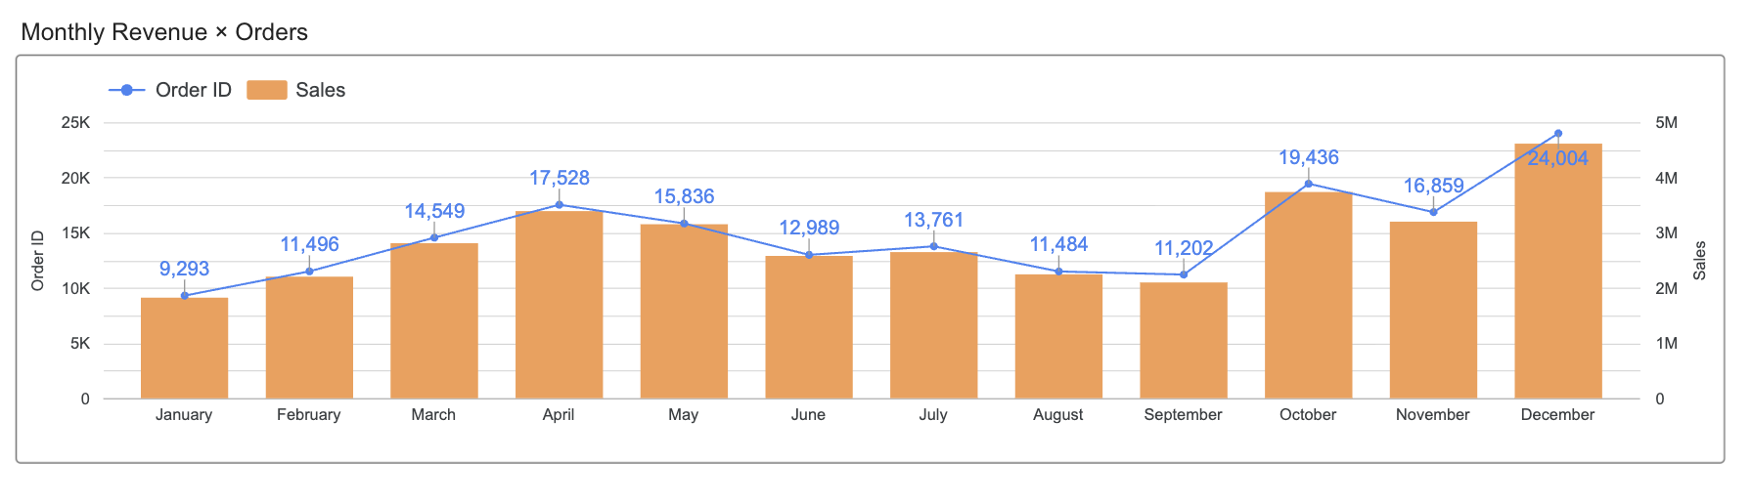
Looking at the Revenue by Month chart overall, revenue in 2019 did NOT grow steadily but instead formed a "skewed W" curve with 3 distinct phases:

Period | Months | Description | Revenue Range | Change (%)
Growth Phase | Jan → Apr | 3 consecutive months up | $1.82M → $3.39M | +86.1%
Decline Phase | May → Sep | 5-month decline in 2 waves (May-Jun ↓, Jul brief recovery, Aug-Sep ↓) | $3.15M → $2.10M | -33.4%
Surge Phase | Oct → Dec | 2 peaks (Oct ↑, Nov dip, Dec highest peak) | $3.74M → $4.61M | +23.5%

Note: April (Apr) is the peak of the Growth Phase. September (Sep) is the absolute bottom — the pivot point between Decline and Surge. The largest jump of the year occurs from Sep ($2.10M) → Oct ($3.74M), an increase of +78.2% in a single month.
The question is: Why do these 3 phases exist? Why does revenue grow then decline? Why does it explode after declining? Let's dive deep into each phase.

III. GROWTH PHASE (JANUARY → APRIL): Post-holiday recovery and steady demand buildup
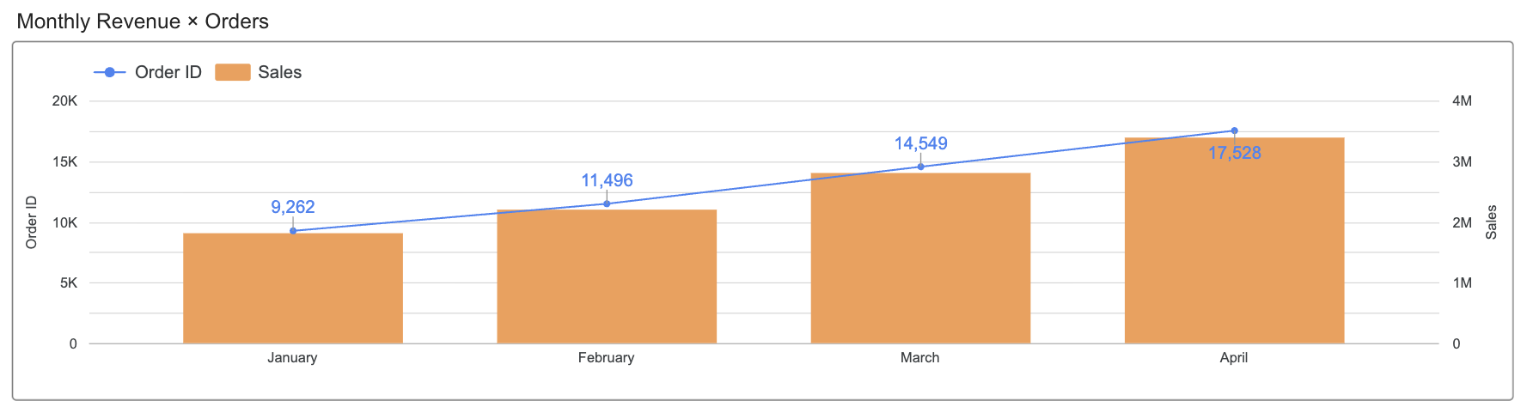

Metric | January | February | March | April
Revenue | $1,822,257 | $2,202,022 | $2,807,100 | $3,390,670
MoM Revenue Change | — | +20.8% | +27.5% | +20.8%
Orders | 9,293 | 11,496 | 14,549 | 17,528
MoM Order Change | — | +23.7% | +26.6% | +20.5%

Over 3 consecutive months, revenue grew at an average of +23.0%/month. Total increase from Jan to Apr was +86.1% (+$1,568,414).

3.1 JANUARY PROFILE — What does the lowest month look like?
January recorded just $1.81M with 9,262 orders — the lowest of all 12 months. Breaking down by product:

SubCategory | Revenue Jan | % of Revenue | Orders | Avg Price
Laptops | $614,798 | 33.9% | 450 | $1,366
Phones | $506,100 | 27.9% | 817 | $617
Monitors | $327,487 | 18.1% | 1,255 | $265
Headphones | $200,955 | 11.1% | 2,457 | $82
TVs | $72,900 | 4.0% | 243 | $300
Laundry | $48,600 | 2.7% | 81 | $600
Cables | $32,509 | 1.8% | 2,227 | $13
Batteries | $10,237 | 0.6% | 2,114 | $3

Key observations:
- HIGH-VALUE items (Laptops $1,366 + Phones $617) account for 61.8% of revenue but only 1,267 orders (13.1% of total) — spending on expensive products is at a very low level
- LOW-PRICE items (Cables $13 + Batteries $3) dominate order count (4,341 orders = 45.0%) but contribute only 2.4% of revenue
- Headphones (2,457 orders) sits in between: high volume but at $82/unit, moderate revenue contribution (11.1%)
- Laundry + TVs: very few orders (81 + 243) — these are bulky/high-value products with the lowest purchase volume

→ January shows a clear pattern: buyers still place orders (mostly small, cheap accessories), but HIGH-VALUE PRODUCTS are purchased at very low volume — notably Laptops at just 450 orders, Laundry at only 81 orders.

3.2 FEBRUARY-APRIL: DEMAND RECOVERS — WHICH GROUPS GREW?

SubCategory | Jan → Apr Revenue | Growth % | Δ Absolute
Laptops | $615K → $1,162K | +89.0% | +$546,998
Phones | $506K → $921K | +82.0% | +$415,000
Monitors | $327K → $623K | +90.2% | +$295,379
Headphones | $201K → $381K | +89.7% | +$180,342
TVs | $73K → $138K | +89.3% | +$65,100
Laundry | $49K → $83K | +71.6% | +$34,800
Cables | $33K → $63K | +92.5% | +$30,081
Batteries | $10K → $20K | +91.7% | +$9,383
Key findings:
- ALL 8 SubCategories grew +71% to +92% — no group was left behind
- However, ABSOLUTE increases differ dramatically: Top 3 (Laptops + Phones + Monitors) contributed +$1,257,377, accounting for 79.7% of the total $1,577,084 increase
- Laundry grew the slowest (+71.6%) and was the ONLY group that declined from Jan→Feb (-3.7%) before recovering sharply Feb→Mar (+44.9%)

3.3 THE FIXED REVENUE ENGINE — Does the product mix shift between low and high months?

Revenue share comparison between the lowest month (Jan) and highest month (Apr):
SubCategory | % Jan | % Apr | Change
Laptops | 33.9% | 34.3% | +0.3%
Phones | 27.9% | 27.2% | -0.7%
Monitors | 18.0% | 18.4% | +0.3%
Headphones | 11.1% | 11.2% | +0.2%
TVs | 4.0% | 4.1% | +0.1%
Laundry | 2.7% | 2.5% | -0.2%
Cables | 1.8% | 1.8% | +0.1%
Batteries | 0.6% | 0.6% | 0.0%

Remarkable finding: the revenue share DOES NOT CHANGE (maximum shift of only 0.7pp). This means:
- Revenue structure is extremely stable — even though April revenue is 1.86x January, each product group's contribution remains nearly identical
- Laptops + Phones + Monitors consistently account for ~80% of revenue in BOTH the lowest and highest months → this is the FIXED GROUP that determines the business's revenue
- No "shift" occurred — buyers did not switch from expensive to cheap products or vice versa; ALL GROUPS grew at the same pace

→ The Growth Phase is a classic "rising tide lifts all boats" pattern: the entire market grew uniformly, with no single product group driving a breakout or falling behind. The only difference between the lowest and highest months is ORDER VOLUME, not product mix.

3.4 CUSTOMER BEHAVIOR CONTEXT

January falls right after the biggest shopping season of the year (Black Friday, Christmas, New Year) — a period when most purchasing demand was already released in November-December. Customers enter January in a "already bought enough" state, pushing order volume to the year's lowest (9,262 orders).

From February onward, purchasing demand recovered naturally following the consumption cycle: electronics have usage and replacement lifecycles, accessories need periodic replenishment. Notably, the recovery pace was very consistent (+21-27%/month) and spread across ALL product groups — indicating this was not triggered by any specific event, but rather the market's natural return to baseline after a post-holiday spending pause.

IV. DECLINE PHASE (MAY → SEPTEMBER): 5 months of decline in 2 waves — which product groups were hit hardest?
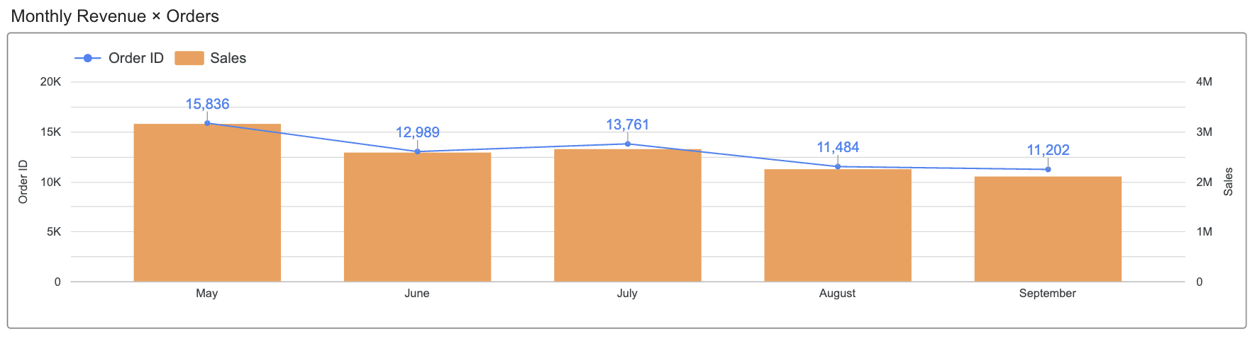

Month | Revenue | MoM Change | Orders | MoM Orders
May | $3,152,607 | -7.0% | 15,836 | -9.7%
Jun | $2,577,802 | -18.2% | 12,989 | -18.0%
Jul | $2,647,776 | +2.7% | 13,761 | +5.9%
Aug | $2,244,468 | -15.2% | 11,484 | -16.6%
Sep | $2,097,560 | -6.5% | 11,202 | -2.5%

Right after the April peak, revenue declined continuously for 5 months (except a brief recovery in July). Total decline from May to Sep: -33.4% (-$1,055,047). If measured from the Apr peak: -38.1% (-$1,293,110).

4.1 WAVE 1 (APR → JUN): Not all categories declined at the same pace
The transition from Apr (peak) to May reveals an interesting pattern — the decline did NOT hit all product groups equally:

SubCategory | Revenue Apr | Revenue May | Apr→May | Revenue Jun | May→Jun
Laptops | $1,161,796 | $1,161,496 | -0.03% | $919,197 | -20.9%
Laundry | $83,400 | $84,000 | +0.7% | $58,800 | -30.0%
Phones | $921,100 | $810,000 | -12.1% | $669,700 | -17.3%
Monitors | $622,867 | $558,939 | -10.3% | $469,242 | -16.0%
Headphones | $381,296 | $344,831 | -9.6% | $291,013 | -15.6%
TVs | $138,000 | $119,700 | -13.3% | $110,100 | -8.0%
Cables | $62,591 | $55,734 | -11.0% | $45,237 | -18.8%
Batteries | $19,620 | $17,906 | -8.7% | $14,513 | -19.0%

Key observation:
- Laptops was virtually FLAT (-0.03%, just $300 difference) — the highest-priced product showed the strongest resistance to decline
- Laundry actually INCREASED (+0.7%) — another high-value product holding steady
- Meanwhile Phones (-12.1%), TVs (-13.3%), and Monitors (-10.3%) dropped immediately
- This suggests: buyers of the most expensive items (Laptops $1,366, Laundry $600) still purchased in May, while mid-range and accessory categories pulled back first
By June, the decline deepened across ALL categories. The sharpest drops: Laundry -30.0% (the May holdout collapsed), Laptops -20.9% (finally fell hard), Batteries -19.0%, Cables -18.8%.

4.2 JULY RECOVERY: Which categories bounced back?
July showed a brief +2.7% recovery. But it was NOT uniform:

SubCategory | Jun → Jul | Recovery pattern
Laundry | +9.2% | Strongest bounce
TVs | +8.7% | Strong bounce
Cables | +8.7% | Strong bounce
Headphones | +5.8% | Moderate
Monitors | +4.6% | Moderate
Batteries | +3.5% | Weak
Laptops | +2.8% | Weak
Phones | -2.0% | NO recovery

Notable: Phones was the ONLY category that did NOT recover in July — it continued declining (-2.0%). This makes Phones the most consistently declining product across the entire phase: it dropped every single month from Apr to Sep without exception.

4.3 WAVE 2 (AUG → SEP): Continued decline to the bottom
After July's brief bounce, Aug-Sep resumed the downward trend. By September (the absolute bottom):

SubCategory | Apr → Sep Revenue | Decline % | Revenue Change
Laundry | $83K → $46K | -45.3% | -$37,800
Phones | $921K → $533K | -42.1% | -$388,200
Monitors | $623K → $396K | -36.5% | -$227,352
Laptops | $1,162K → $739K | -36.4% | -$423,199
Headphones | $381K → $244K | -36.1% | -$137,556
TVs | $138K → $88K | -36.1% | -$49,800
Batteries | $20K → $13K | -36.0% | -$7,070
Cables | $63K → $40K | -35.4% | -$22,134

Key findings:
- Laundry declined the MOST (-45.3%) — from being the last holdout in May to the steepest faller overall
- Phones declined second most (-42.1%) and was the only product that declined EVERY month without exception
- The remaining 6 categories clustered tightly at -35% to -36.5%, showing a very uniform decline
- Top 3 (Laptops + Phones + Monitors) contributed -$1,038,750, accounting for 80.3% of the total decline — mirroring the 79.7% contribution during growth

4.4 REVENUE STRUCTURE: Did the product mix shift during the decline?

SubCategory | % Apr | % Sep | Change
Laptops | 34.3% | 35.2% | +0.9%
Phones | 27.2% | 25.4% | -1.8%
Monitors | 18.4% | 18.9% | +0.5%
Headphones | 11.2% | 11.6% | +0.4%
TVs | 4.1% | 4.2% | +0.1%
Laundry | 2.5% | 2.2% | -0.3%
Cables | 1.8% | 1.9% | +0.1%
Batteries | 0.6% | 0.6% | 0.0%

The only notable shift: Phones lost -1.8% share (the steepest consistent decliner), while Laptops gained +0.9% (held up longest in May). But overall, the structure remained remarkably stable — Laptops + Phones + Monitors still accounted for 79.4% at the bottom vs 79.8% at the peak.

→ The Decline Phase mirrors the Growth Phase in reverse: order volume dropped while the product mix stayed nearly unchanged. The key difference is in the TIMING — not all categories declined simultaneously. Laptops and Laundry resisted initially (May), then fell sharply (Jun onward). Phones was the most vulnerable, declining every single month. But by September, all categories had converged to a similar ~36% decline, confirming the same "falling tide lowers all boats" pattern.

4.5 CUSTOMER BEHAVIOR CONTEXT

The May-Sep period coincides with the US summer — a time when consumer behavior shifts distinctly: people prioritize travel, outdoor activities, and experience-based spending over online product purchases. This explains why order volume declined evenly across ALL product groups, not just specific categories.

July's brief recovery (+2.7%) coincides with mid-year shopping events in the US (July 4th Independence Day sales, Amazon Prime Day) — creating a short-term demand stimulus before the downward trend continued.

September hit the deepest bottom not just because of extended summer effects, but also due to the "anticipation effect": customers know the biggest sale season is approaching (Black Friday, Holiday Season) and DELIBERATELY delay purchases. This is a well-documented e-commerce phenomenon called the "pre-holiday spending freeze" — Sep AOV also dropped to $187.25 (the year's lowest), showing that even those who did buy shifted toward cheaper items.

5. COMPARING GROWTH vs DECLINE: WHAT'S DIFFERENT? WHY?

Metric | Growth Phase (Jan→Apr) | Decline Phase (May→Sep)
Duration | 3 months | 5 months
Amplitude of change | +86.1% (+$1.57M) | -33.4% (-$1.06M)
Speed | +23.0%/month | -6.7%/month
Driver | Volume surging | Volume gradually fading
AOV | Stable ($191–$196) | Stable then declining ($187–$199)
Category mix | Uniform across all | Uniform across all

The most important difference: SPEED
- The growth phase was MUCH FASTER: +23%/month over 3 months
- The decline phase was SLOWER: -6.7%/month but stretched over 5 months
- Meaning: Customers return to shopping QUICKLY after the holiday break, but leave SLOWLY during summer — a positive signal for retention

Similarities:
- Both phases were driven by VOLUME (order count), not VALUE (AOV)
- Category mix did not change — Electronics consistently held 83-84%, product structure remained stable
- This confirms: revenue fluctuations are entirely due to CUSTOMER COUNT, not changes in shopping behavior

6. SURGE PHASE (OCTOBER → DECEMBER): Explosion from the bottom with 2 peaks — which product groups led the recovery?
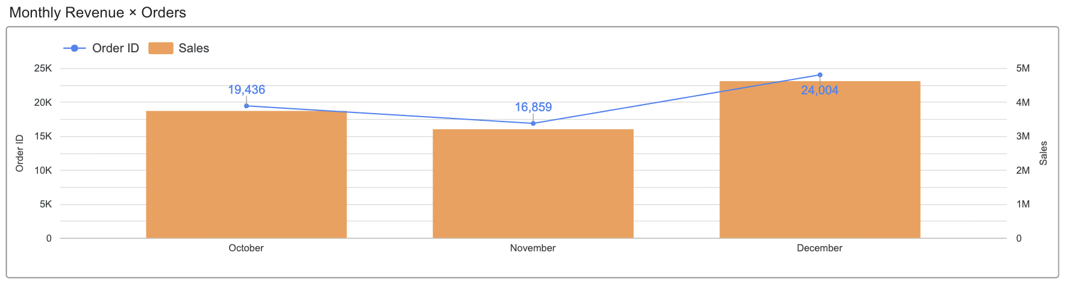
After hitting bottom at September ($2.10M — the pivot point), revenue exploded back:
Month | Revenue | MoM Change | Orders | MoM Orders
Oct | $3,736,727 | +78.2%* | 19,436 | +73.5%*
Nov | $3,199,603 | -14.4% | 16,859 | -13.3%
Dec | $4,613,443 | +44.2% | 24,004 | +42.4%

(*MoM compared to Sep — the pivot point bottom month)

This is the most impressive phase: from the Sep bottom, revenue increased +119.9% in just 3 months to the $4.61M peak (Dec). Within the Surge Phase itself (Oct→Dec), revenue grew +23.5% from $3.74M to $4.61M.

(a) PEAK 1 — OCTOBER: The largest leap of the year (+78.1%)

Sep → Oct nearly DOUBLED in a single month. Breaking down by product group:
SubCategory | Revenue Sep | Revenue Oct | Sep→Oct
Laptops | $738,598 | $1,353,495 | +83.3%
TVs | $88,200 | $157,200 | +78.2%
Monitors | $395,515 | $702,764 | +77.7%
Phones | $532,900 | $940,600 | +76.5%
Headphones | $243,741 | $424,401 | +74.1%
Cables | $40,457 | $70,322 | +73.8%
Batteries | $12,550 | $21,345 | +70.1%
Laundry | $45,600 | $66,600 | +46.1%

Key findings:
- 7 out of 8 groups surged +70% to +83% — very uniform growth, mirroring the "rising tide" pattern from the Growth Phase
- Laptops led the recovery (+83.3%) — the group that held out longest during the Decline Phase now also recovered the strongest
- Laundry is the SOLE OUTLIER: only +46.1%, far below the other groups. This was the steepest decliner in the Decline Phase (-45.3%) and now also the slowest to recover — indicating this group suffered deeper demand damage and needs more time to bounce back

(b) NOVEMBER DIP: All groups declined, but at very different rates

November dropped -14.4% vs October — a dip between the two peaks. Looking at the details:

SubCategory | Revenue Oct | Revenue Nov | Oct→Nov
Laptops | $1,353,495 | $1,121,996 | -17.1%
Monitors | $702,764 | $587,657 | -16.4%
Cables | $70,322 | $59,999 | -14.7%
TVs | $157,200 | $138,000 | -12.2%
Headphones | $424,401 | $375,326 | -11.6%
Phones | $940,600 | $832,100 | -11.5%
Batteries | $21,345 | $19,125 | -10.4%
Laundry | $66,600 | $65,400 | -1.8%

Key findings:
- Laptops declined the MOST (-17.1%) — the opposite of its behavior in the Decline Phase, where it held out the longest. This shows October absorbed a massive wave of Laptop demand, causing a sharp November pullback
- Monitors (-16.4%) also dropped steeply — high-priced Electronics were hit hardest
- Laundry barely declined (-1.8%) — the slowest recoverer in October now held the steadiest in November, as its demand hadn't been fully released yet

(c) PEAK 2 — DECEMBER: Highest peak of the year ($4.61M)

Nov → Dec surged +44.2%, reaching a record high. December contributed 13.4% of total annual revenue — this single month equals 2.53x January.

SubCategory | Revenue Nov | Revenue Dec | Nov→Dec | Revenue Change
Laptops | $1,121,996 | $1,632,095 | +45.5% | +$510,098
Phones | $832,100 | $1,176,800 | +41.4% | +$344,700
Monitors | $587,657 | $866,438 | +47.4% | +$278,780
Headphones | $375,326 | $526,742 | +40.3% | +$151,416
Laundry | $65,400 | $99,600 | +52.3% | +$34,200
TVs | $138,000 | $199,800 | +44.8% | +$61,800
Cables | $59,999 | $84,988 | +41.6% | +$24,989
Batteries | $19,125 | $26,981 | +41.1% | +$7,856

Key findings:
- Laundry surged the MOST (+52.3%) — a delayed explosion after "lagging" in October and holding steady in November
- Monitors (+47.4%) and Laptops (+45.5%) also bounced back strongly after being the deepest decliners in November
- All groups grew +40% to +52% — uniform growth confirming the broad-based recovery pattern

d) FULL SURGE: FROM BOTTOM (SEP) TO PEAK (DEC) — Did the product mix shift?

SubCategory | Sep → Dec Revenue | Growth % | Revenue Change
TVs | $88K → $200K | +126.5% | +$111,600
Laptops | $739K → $1,632K | +121.0% | +$893,497
Phones | $533K → $1,177K | +120.8% | +$643,900
Monitors | $396K → $866K | +119.1% | +$470,923
Laundry | $46K → $100K | +118.4% | +$54,000
Headphones | $244K → $527K | +116.1% | +$283,002
Batteries | $13K → $27K | +115.0% | +$14,430
Cables | $40K → $85K | +110.1% | +$44,531

Total increase: +$2,515,883. Top 3 (Laptops + Phones + Monitors) contributed +$2,008,320 = 79.8% — NEARLY IDENTICAL to the contribution during growth (79.7%) and decline (80.3%).

Revenue share:

SubCategory | % Sep | % Dec | Change
Laptops | 35.2% | 35.4% | +0.2%
Phones | 25.4% | 25.5% | +0.1%
Monitors | 18.9% | 18.8% | -0.1%
Headphones | 11.6% | 11.4% | -0.2%
TVs | 4.2% | 4.3% | +0.1%
Laundry | 2.2% | 2.2% | 0.0%
Cables | 1.9% | 1.8% | -0.1%
Batteries | 0.6% | 0.6% | 0.0%

→ The Surge Phase confirms for the third time the same pattern: revenue surged +119.9% yet each product group's share barely moved (maximum 0.2% shift). Whether at the bottom or the peak, Laptops + Phones + Monitors consistently account for ~80% of revenue. The key difference from Growth and Decline: within the Surge Phase, there is a PHASE LAG between groups — Laundry recovered one beat slower (weak Oct, steady Nov, burst in Dec), while Laptops and Monitors surged hardest in Oct then dipped deepest in Nov before reaching the Dec peak.

(e) CUSTOMER BEHAVIOR CONTEXT

The Surge Phase coincides with the largest year-end shopping season in the US — a chain of consecutive events that strongly stimulate consumer spending:

- OCTOBER: The holiday shopping season begins early. After 5 months of decline (May-Sep), pent-up demand is released all at once. Early holiday deals and pre-Black Friday promotions appear from early October, creating the +78.1% jump. The data shows ALL groups (except Laundry) surged +70-83%, confirming this was broad-based purchasing demand, not driven by any single event.
- NOVEMBER: Despite Black Friday (end of month) and Cyber Monday, revenue actually DROPPED -14.4% vs October. Behavioral explanation: October had already absorbed a large portion of early demand. During the first 3 weeks of November, customers shifted into a "waiting for the exact sale day" mode → revenue concentrated mostly in the final week but couldn't compensate for 3 quiet weeks. Additionally, some Black Friday orders may have fallen into early December due to order processing times.
- DECEMBER: Christmas shopping season — the biggest gift-buying period of the year. This is why December surpassed even October: gift-buying demand stimulated purchases across all categories, especially Laptops and Phones — the two most popular gift products, contributing +$510K and +$345K in absolute growth from Nov→Dec.

7. COMPARING THE 3 PEAK MONTHS: OCT vs NOV vs DEC

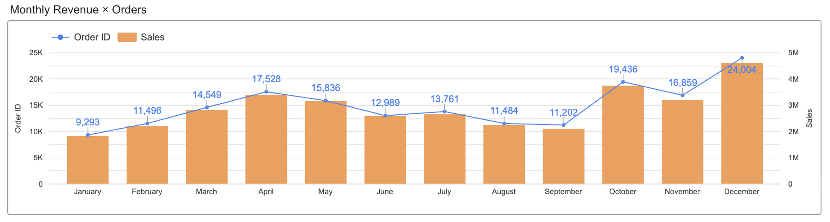
Metric | Oct | Nov | Dec
Revenue | $3,736,727 | $3,199,603 | $4,613,443
Orders | 19,436 | 16,859 | 24,004
AOV | $192.26 | $189.79 | $192.19
Annual Share | 10.8% | 9.3% | 13.4%

These 3 months combined = $11,549,773 = 33.5% of total annual revenue. Meaning 1/4 of the time (3/12 months) generates 1/3 of revenue.

Why is it Dec > Oct > Nov (not Dec > Nov > Oct)?
- Oct: The "spring rebound" after 5 months of decline — pent-up demand released
- Nov: Customers waiting for Black Friday → revenue "stuck" at end of month, couldn't compensate
- Dec: Christmas gift-buying pressure + year-end deals → everyone spends, including those who already bought in Oct

Interesting point: AOV barely CHANGED across the 3 months ($189–$192)
- The holiday season doesn't make customers buy more expensive items — they just BUY MORE
- Dec had 24,004 orders vs Oct 19,436 → a difference of 4,568 orders, which is exactly the additional "gift buyers"

8. REVENUE AND ORDERS CORRELATION: A VOLUME-DRIVEN BUSINESS

Month | Revenue | Orders | AOV
Jan | $1,822,257 | 9,293 | $196.09
Feb | $2,202,022 | 11,496 | $191.55
Mar | $2,807,100 | 14,549 | $192.94
Apr | $3,390,670 | 17,528 | $193.44
May | $3,152,607 | 15,836 | $199.08
Jun | $2,577,802 | 12,989 | $198.46
Jul | $2,647,776 | 13,761 | $192.41
Aug | $2,244,468 | 11,484 | $195.44
Sep | $2,097,560 | 11,202 | $187.25
Oct | $3,736,727 | 19,436 | $192.26
Nov | $3,199,603 | 16,859 | $189.79
Dec | $4,613,443 | 24,004 | $192.19

AOV fluctuates within an extremely narrow range: $187.25 (Sep) → $199.08 (May), a spread of only $11.83.

Meanwhile, Orders fluctuate widely: 9,293 (Jan) → 24,004 (Dec), a 2.58x spread.

Conclusion: This is a 100% Volume-Driven Business. Revenue increases and decreases are entirely dependent on ORDER COUNT. The value per order ($193 ± $6) is virtually a constant. All revenue growth strategies must focus on ACQUISITION (attracting more customers) and FREQUENCY (increasing purchase frequency), not UPSELL (increasing order value).

9. KEY TAKEAWAYS
- REVENUE FOLLOWS A 3-PHASE CYCLE: Growth (Jan-Apr) → Decline (May-Sep) → Surge (Oct-Dec). This cycle accurately reflects US e-commerce consumer rhythms: post-holiday recovery → summer lull → holiday explosion.
- VOLUME DETERMINES EVERYTHING: AOV is stable at $193 ± $6 across all 12 months. All revenue fluctuations are driven by order count. Strategy must prioritize acquiring new customers and increasing purchase frequency.
- Q4 IS "HARVEST SEASON": The final 3 months contribute 33.5% of annual revenue. Marketing budget should be heavily allocated to Q4, especially October (the spring rebound) and December (the absolute peak).
- SEPTEMBER IS AN OPPORTUNITY: The deepest bottom ($2.10M) right before the explosion. An "early bird deals" campaign in September could pull some Q4 demand forward, flattening the bottom and reducing December logistics pressure.
- DEC/JAN RATIO = 2.53x: The gap between the highest and lowest months is too large. A customer retention strategy post-holiday season is needed to reduce the "post-holiday slump" in January.

PURCHASING TIME PATTERNS — INSIGHT ANALYSIS

1. THE BIG PICTURE — "TWIN PEAK" MODEL
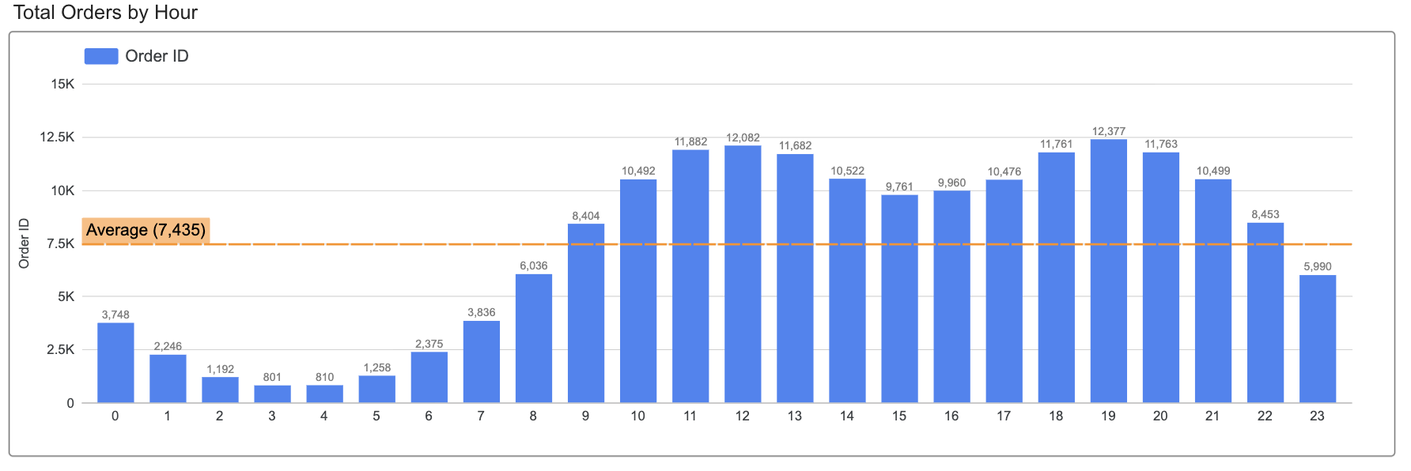

Looking at the Total Orders by Hour chart overall, online shopping behavior throughout the day forms a clear "Twin Peak" pattern:

Metric | Value
Average Line | 7,434 orders/hour
Hours above average | 14 hours (9:00–22:00)
Hours below average | 10 hours (23:00–8:00)
Highest hour | 19:00 (12,377 orders)
Lowest hour | 3:00 (801 orders)
Peak/Trough ratio | 15.5x

Two peaks appear at:
- Lunch peak: 12:00 (12,082 orders)
- Evening peak: 19:00 (12,377 orders) — higher than the lunch peak

The question: Why are there 2 peaks? Why is the evening peak higher than the lunch peak? Let's dive deep into each time slot.

2. E-COMMERCE BEHAVIORAL SEGMENTS BY TIME
Online shopping behavior follows customers' daily life rhythms. Unlike brick-and-mortar stores (limited by opening hours), e-commerce operates 24/7 — but customers still shop according to their "life rhythm." This can be divided into 7 behavioral segments:
Segment | Time Slot | Orders | Share | E-commerce Behavior
Deep Sleep | 2:00–5:00 | 4,061 | 2.3% | Nearly zero online activity
Wake & Browse | 6:00–8:00 | 12,247 | 6.9% | Waking up, checking phone in bed, quick browsing
Commute & Work | 9:00–11:00 | 30,778 | 17.2% | Browsing on commute, tab shopping between work tasks
Lunch Break | 12:00–13:00 | 23,764 | 13.3% | Office lunch break, concentrated shopping
Afternoon Plateau | 14:00–17:00 | 40,719 | 22.8% | Shopping between work tasks, slight decline
Evening at Home | 18:00–21:00 | 46,400 | 26.0% | Home on couch/computer, intentional shopping
Late Night Wind-Down | 22:00–1:00 | 20,437 | 11.5% | Phone browsing in bed, gradually decreasing

3. DEEP DIVE INTO EACH TIME SLOT — WHAT DO CUSTOMERS BUY, AND WHEN?

Before diving into each time slot, here's an overview of product mix and AOV across all 7 segments:
|
Segment | AOV | Laptops | Phones | Monitors | Headphones | Others
Deep Sleep (2-5h) | $189.67 | 34.5% | 25.9% | 19.1% | 11.5% | 9.0%
Wake & Browse (6-8h) | $194.77 | 36.4% | 25.8% | 17.7% | 11.2% | 8.9%
Commute & Work (9-11h) | $191.17 | 34.8% | 26.5% | 18.3% | 11.7% | 8.7%
Lunch Break (12-13h) | $188.19 | 34.1% | 26.0% | 18.9% | 11.9% | 9.1%
Afternoon (14-17h) | $197.92 | 36.4% | 25.2% | 18.4% | 11.0% | 9.0%
Evening (18-21h) | $193.02 | 35.0% | 26.0% | 18.6% | 11.4% | 9.0%
Late Night (22-1h) | $193.59 | 35.1% | 26.1% | 18.7% | 11.6% | 8.5%
Overall average | $193.29 | ~35% | ~26% | ~18.5% | ~11.5% | ~9%

KEY FINDING: Product mix does NOT change by time of day. Laptops always account for ~35%, Phones ~26%, Monitors ~18.5% — whether it's 3 AM or 7 PM. AOV fluctuates within a narrow range of $188–$198, with a maximum gap of only $9.73.

→ This means: time of day changes HOW MANY people buy, but does NOT change WHAT THEY BUY.

3.1. DEEP SLEEP — 2:00–5:00 (2.3%, 4,061 orders, AOV $189.67)
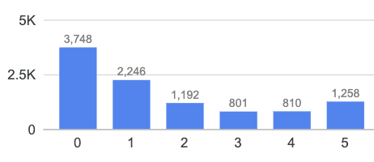

- 4 hours produce only 4,061 orders and $770,245 revenue — LESS than a single peak hour (19:00 = 12,377 orders)
- Absolute trough: 3:00 AM — 801 orders
- AOV $189.67 — slightly below average, but product mix remains identical (Laptops 34.5%, Phones 25.9%)

This is physiological sleep time — virtually no one is awake to shop. Yet e-commerce still records 801 orders at 3AM: there's always a small group of "night owls" or customers in other time zones placing orders. A brick-and-mortar store would have 0 orders during this window — this is a natural advantage of the online channel.

3.2. WAKE & BROWSE — 6:00–8:00 (6.9%, 12,247 orders, AOV $194.77)

- Orders ramp up fastest of the day: 6:00 (2,375) → 7:00 (3,836) → 8:00 (6,036) — up 154% in just 2 hours
- Revenue: $2,385,316 (6.9% of total)
- AOV $194.77 — above average, product mix stable (Laptops 36.4%)

Characteristic smartphone behavior: wake up → check phone in bed → see products saved from the night before → place a quick order before leaving home. Many orders in this window are decisions "incubated" overnight.

3.3. COMMUTE & WORK — 9:00–11:00 (17.2%, 30,778 orders, AOV $191.17)

Hour | Orders | HoH (vs previous hour)
9:00 | 8,404 | +39.2% vs 8:00
10:00 | 10,492 | +24.9%
11:00 | 11,882 | +13.2%

- Revenue: $5,883,928 (17.1% of total)
- Orders increase continuously across 3 hours, building toward the lunch peak

Two interleaving behaviors: (a) Commuting to work (9:00) — browsing phones on public transit, reviewing cart, finalizing "incubated" orders. 9:00 surges +39.2% vs 8:00, aligning with US peak commute hours. (b) Work hours tab shopping (10:00–11:00) — "tab shopping" between work tasks with stable internet and larger screens.

This is the "upward ramp" leading to the lunch peak: 8,404 → 11,882 orders, increasing non-stop.

3.4. LUNCH BREAK — 12:00–13:00 (13.3%, 23,764 orders, AOV $188.19) — FIRST PEAK

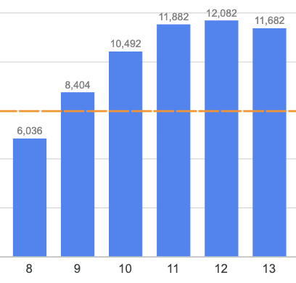

Hour | Orders | Revenue
12:00 | 12,082 | $2,316,821
13:00 | 11,682 | $2,155,390

- Total revenue: $4,472,211 (13.0% of total)
- 12:00 is THE DAY'S SECOND HIGHEST hour (only behind 19:00)
- AOV $188.19 — LOWEST among all 7 segments

The lowest AOV here is NOT because customers buy cheaper products — Laptops (34.1%) and Phones (26.0%) share is virtually identical to other time slots. The AOV fluctuation falls within the narrow $188–$198 range and reflects random variation per order, not a change in shopping behavior.

Behavior: Lunch break is the first official free time of the day. All browse activity from the morning (Wake & Browse + Commute & Work) accumulates and gets "checked out" here. Just 2 hours produce 23,764 orders — density of 11,882 orders/hour, 1.6x the average (7,434).

3.5. AFTERNOON PLATEAU — 14:00–17:00 (22.8%, 40,719 orders, AOV $197.92)

- Decreases from the 13:00 peak but NEVER falls below average (7,434)
- Lowest point: 15:00 — 9,761 orders (still 31.3% above average)
- AOV $197.92 — HIGHEST among all 7 segments
- Revenue: $8,059,185 (23.4% of total)

The highest AOV of the day appears here, not in the evening. However, the gap is only $4.63 vs Evening ($193.02) — too small to conclude any meaningful difference. Product mix remains identical: Laptops 36.4%, Phones 25.2%.

Behavior: Customers return to work after lunch, less free time but can still "tab shop" between tasks. Orders decline but never collapse — this is the "bridge" between the 2 peaks, keeping e-commerce's "effective window" running continuously for 14 hours (9:00–22:00 all above average).

3.6. EVENING AT HOME — 18:00–21:00 (26.0%, 46,400 orders, AOV $193.02) — HIGHEST PEAK
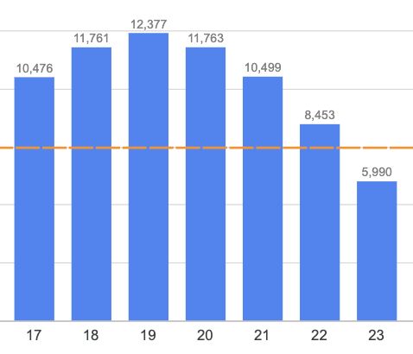

Hour | Orders | Revenue
18:00 | 11,761 | $2,219,348
19:00 | 12,377 | $2,412,939
20:00 | 11,763 | $2,281,716
21:00 | 10,499 | $2,042,001

- Total revenue: $8,956,004 (26.0% of total) — highest among all 7 segments
- 19:00 = THE DAY'S ABSOLUTE PEAK (12,377 orders)
- AOV $193.02 — near average, product mix stable (Laptops 35.0%, Phones 26.0%)

Why is this the highest peak? After 18:00, most have finished work. Home on the couch/computer, with the LONGEST free time of the day to browse, compare, and decide — no time pressure like lunch breaks. 4 consecutive hours (18–21h) all above 10,000 orders, creating the largest revenue block.

"Golden Hour" 19:00: The absolute peak — customers have finished dinner, begin their most focused online shopping session. 19:00 is the hottest hour in 5/7 days on the Heatmap.

3.7. LATE NIGHT WIND-DOWN — 22:00–1:00 (11.5%, 20,437 orders, AOV $193.59)

- Rapid decline: 22:00 (8,453) → 0:00 (3,748) → 1:00 (2,246)
- But 22:00 is still above average (8,453 > 7,435)
- AOV $193.59 — near average, product mix unchanged

Customers begin going to bed. "Bed-scrolling" behavior generates orders but gradually diminishes. Many browse but don't buy immediately — they save and purchase the next morning (linking to Wake & Browse at 6:00–8:00).

4. NOON PEAK vs EVENING PEAK — WHAT DOES THE DATA SHOW?

Comparing the 2 peak hours:

Metric | Noon Peak 12:00 | Evening Peak 19:00 | Difference
Orders | 12,082 | 12,377 | +295 orders
Revenue | $2,316,821 | $2,412,939 | +$96,118
AOV | $191.76 | $194.95 | +$3,19

Comparing the 2 expanded peak zones:

Metric | Noon Zone (10–13h) | Evening Zone (18–21h) | Difference
Total orders | 46,138 | 46,400 | +262 orders
Total revenue | $8,717,108 | $8,956,004 | +$238,896
AOV | $188.94 | $193.02 | $4.08

Product mix at the 2 peak zones:

SubCategory | Noon Zone | Evening Zone | Difference
Laptops | 34.2% | 35.0% | +0.8%
Phones | 26.4% | 26.0% | -0.4%
Monitors | 18.6% | 18.6% | 0.0%
Headphones | 11.8% | 11.4% | -0.4%
TVs | 4.2% | 4.2% | 0.0%
Laundry | 2.2% | 2.4% | +0.2%
Cables | 1.9% | 1.8% | -0.1%
Batteries | 0.6% | 0.6% | 0.0%

RESULT: Product mix at the 2 peak zones is nearly IDENTICAL (max difference 0.8%). Customers buy the SAME ratio of Laptops, Phones, and accessories regardless of noon or evening.

The AOV gap ($188.94 vs $193.02 = $4.08) is too small to conclude evening shoppers "buy more expensive." With identical product mix, the +$238,896 revenue difference between the 2 zones comes purely from the evening zone having 262 MORE orders, not from higher order values.

The real difference between the 2 peaks lies in HOW THEY FORM:
- Noon zone: accumulated from 3 sequential behaviors (commute 9h → work 10-11h → lunch break 12-13h) — orders build gradually then burst at lunch
- Evening zone: burst from a single behavior — home, relaxed, with long uninterrupted free time (4 hours)

The 2 peak zones produce nearly equal order volume (0.6% difference), same product mix, same AOV range — but entirely different formation mechanisms.

5. HEATMAP ANALYSIS — DAY OF WEEK × HOUR

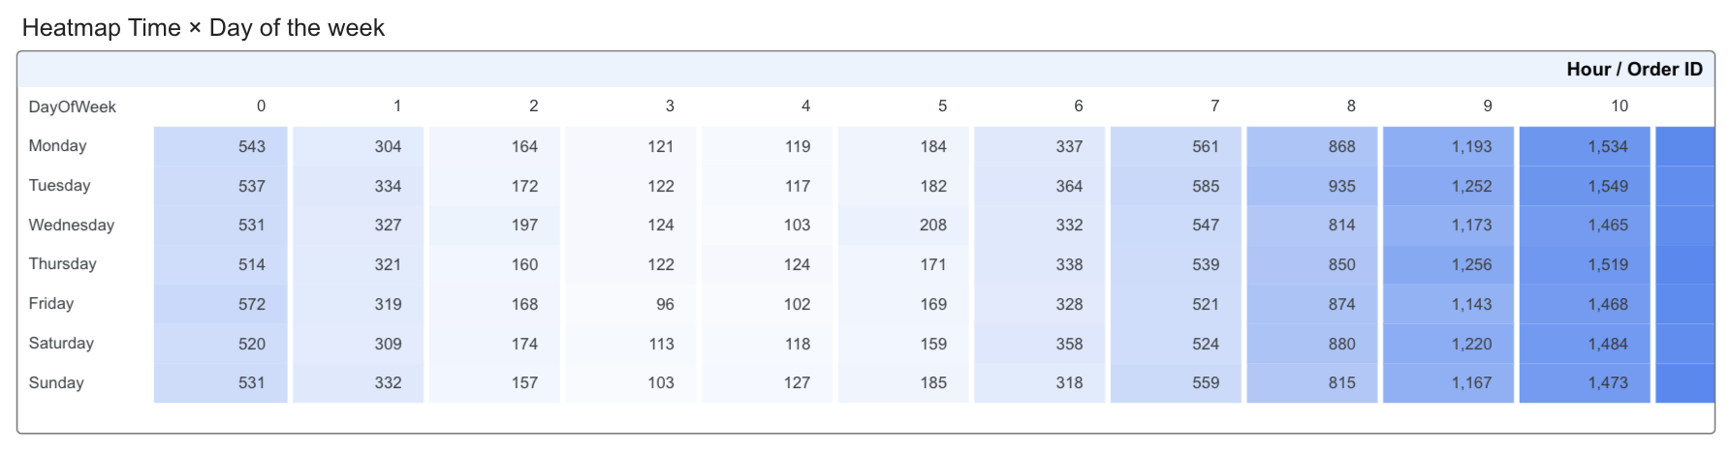

Overall average: 1,062 orders per cell (per day-hour combination)

5.1. Most important finding: ABSOLUTE CONSISTENCY

Every day of the week has exactly 14 out of 24 hours above average. Monday = Tuesday = ... = Sunday. No exceptions.

WHY SO CONSISTENT? This is characteristic of e-commerce: unaffected by store hours, holidays, or street traffic. Online customers shop based on their PERSONAL LIFE RHYTHM (sleep/wake, work/rest), not store schedules. And this rhythm is virtually identical every day.

5.2. Top 5 hottest cells — 19:00 dominates:
1. Friday 19:00 — 1,810 orders (1.70x average)
2. Monday 19:00 — 1,796 orders (1.69x average)
3. Tuesday 18:00 — 1,788 orders (1.68x average)
4. Monday 12:00 — 1,770 orders (1.67x average)
5. Saturday 19:00 — 1,770 orders (1.67x average)

19:00 appears in 3 of the top 5 hottest cells, and is the peak hour in 5 out of 7 days. This is the "E-commerce Golden Hour" — the moment when customers are most psychologically ready to buy: done with work, done with dinner, relaxing.

5.3. Top 5 coldest cells — 3:00–4:00 AM always at the bottom:
1. Friday 3:00 — 96 orders (0.09x average)
2. Sunday 3:00 — 103 orders
3. Wednesday 4:00 — 107 orders
4. Saturday 3:00 — 113 orders
5. Tuesday 4:00 — 117 orders

Hot/Cold ratio: 1,810 / 96 = 18.9x within the same day (Friday). E-commerce has an extremely large intraday fluctuation range.

5.4. Weekday vs Weekend — No Difference

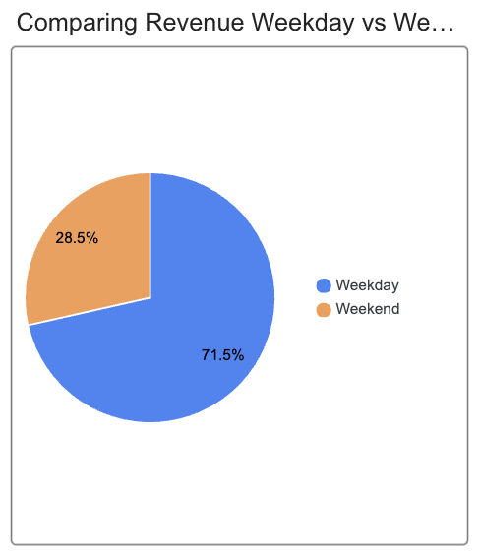

Metric | Weekday | Weekend
Avg orders/day | 487 | 489
Avg revenue/day | $94,105 | $94,582
Difference | — | +0.5%

WHY NO DIFFERENCE? With brick-and-mortar stores, weekends are typically busier because customers have free time to go shopping. But e-commerce breaks this pattern: online customers can buy at any time — a weekday lunch break is just as effective as a Sunday afternoon.

The 71.5% (Weekday) vs 28.5% (Weekend) split on the pie chart only reflects the 5:2 day ratio, NOT a behavioral difference.

6. CONNECTING HOURLY PATTERNS WITH PEAK MONTHS — DOES PRODUCT MIX CHANGE?

From the Overview analysis, we know monthly revenue fluctuates significantly (Jan $1.82M → Dec $4.61M). Two questions:
- Does the HOURLY PATTERN (Twin Peak) change by month?
- Does the PRODUCT MIX change by month?

6.1. Hourly pattern — does NOT change

The Twin Peak model (12h and 19h) remains consistent across all months. What changes during peak months (Oct–Dec) is the SCALE (more orders at every hour), not the SHAPE (still 2 peaks at the same time slots).

6.2. Product mix — ALSO does NOT change

SubCategory | January | April | October | December | Range
Laptops | 33.9% | 34.3% | 36.2% | 35.4% | 2.3%
Phones | 27.9% | 27.2% | 25.2% | 25.5% | 2.7%
Monitors | 18.1% | 18.4% | 18.8% | 18.8% | 0.7%
Headphones | 11.1% | 11.2% | 11.4% | 11.4% | 0.3%
TVs | 4.0% | 4.1% | 4.2% | 4.3% | 0.3%
Laundry | 2.7% | 2.5% | 1.8% | 2.2% | 0.9%
Cables | 1.8% | 1.8% | 1.9% | 1.8% | 0.1%
Batteries | 0.6% | 0.6% | 0.6% | 0.6% | 0.0%

From the lowest month (Jan) to the highest month (Dec), product mix barely changes. Laptops always ~34–36%, Phones ~25–28%, Top 3 (Laptops + Phones + Monitors) consistently ~80% of revenue.

6.3. Dual constant

Combining findings from Section 3 (product mix unchanged by HOUR) and Section 6 (unchanged by MONTH):

→ Product mix is a DUAL CONSTANT: unchanged across time of day, and unchanged across months of the year.

The only thing that changes is SCALE — peak months have more orders per hour, peak hours have more orders than off-peak hours — but the Laptops/Phones/Monitors/accessories ratio stays the same. This is the Volume-Driven characteristic, consistent with the Sales Overview conclusion.
7. KEY TAKEAWAYS & RECOMMENDATIONS

7.1. "TWIN PEAK" STRATEGY FOR E-COMMERCE: The two time slots 10–13h and 18–21h account for 51.9% of total orders in just 8 hours. All digital marketing campaigns (push notifications, emails, flash sales, social media ads) should be scheduled to concentrate on these 2 windows.

7.2. 19:00 IS THE "E-COMMERCE GOLDEN HOUR": The absolute peak of the day, hottest in 5 out of 7 days. All time-sensitive promotions (flash sales, limited deals, countdowns) should prioritize the 19:00 window. This is when customers are at home, relaxed, with the longest free time of the day.

7.3. PRODUCT MIX IS A CONSTANT — NO NEED TO DIFFERENTIATE PRODUCTS BY HOUR: Data shows SubCategory share is nearly IDENTICAL across all time slots (Laptops always ~35%, Phones ~26%). Customers buy the SAME ratio of products whether it's noon or evening. Product promotion strategy should focus on the HOURS WITH MOST ORDERS (18–21h) rather than trying to match specific products to specific hours.

7.4. NO SEPARATE WEEKDAY/WEEKEND STRATEGY NEEDED: Only a 0.5% difference between weekdays and weekends. E-commerce breaks the offline rule of "weekends are busier." The same marketing schedule works effectively every day.

7.5. LEVERAGE "WAKE & BROWSE" 6–9h: Orders increase 254% in 3 hours — many are decisions "incubated" from the previous evening. Send push notifications/emails reminding customers of their "saved cart" at 7:00–8:00 AM to convert last night's browsers into this morning's buyers.

7.6. LOW-TRAFFIC HOURS 2–5h — LOW COST, HIGH EFFICIENCY: Still 4,061 orders/year during the "dead" window — an e-commerce exclusive. Run retargeting ads and scheduled emails during this window: advertising costs are cheapest (less competition), targeting the "night owl" group and customers in different time zones.

7.7. HOURLY PATTERN + PRODUCT MIX = DUAL CONSTANT: The Twin Peak shape doesn't change by month or season. Product mix doesn't change by hour or month. Time-based marketing strategy can be applied consistently year-round — only adjust BUDGET SCALE (increase in Q4), not the SCHEDULE or PRODUCT CATEGORIES promoted.

GEOGRAPHIC ANALYSIS — INSIGHT ANALYSIS

1. GEOGRAPHIC REVENUE DISTRIBUTION

Revenue sources are concentrated across nine major cities, spanning three distinct geographic regions in the United States:
Region | Cities | Revenue | Share
West Coast | San Francisco, Los Angeles, Seattle, Portland | $18,783,021 | 54.5%
East Coast | New York City, Boston, Atlanta | $11,121,458 | 32.2%
South/Central | Dallas, Austin | $4,587,557 | 13.3%
Key Observations:
- West Coast Dominance: The West Coast accounts for over half of total revenue (54.5%), significantly outpacing the East Coast (1.7x higher) and the South/Central region (4.1x higher). This dominance is likely driven by the region's concentration of technology centers (e.g., Silicon Valley), leading to higher demand for electronics and tech accessories.
- Coastal Concentration: A notable pattern is the strong link between revenue and coastal proximity. Seven of the nine cities are coastal or near-coastal (SF, LA, Seattle, Portland, NYC, Boston, Atlanta). The two inland cities, Dallas and Austin, contribute the lowest combined share (13.3%). This reflects a broader US demographic and economic characteristic: the largest and most developed metropolitan areas are situated along the East and West coastlines.

2. TOP 5 CITIES: IN-DEPTH REVENUE ANALYSIS

The five leading cities are significant revenue drivers, collectively contributing 72.0% of the total revenue ($24.84M out of $34.49M).
Rank | City | Revenue | Share | Orders | Geographic/Economic Profile
1 | San Francisco | $8,262,204 | 24.0% | 42,898 | Pacific Coast, Global Tech Hub (Silicon Valley)
2 | Los Angeles | $5,452,571 | 15.8% | 28,498 | Pacific Coast, Entertainment & Population Center
3 | New York City | $4,664,317 | 13.5% | 23,848 | Atlantic Coast, Financial & Banking Center
4 | Boston | $3,661,642 | 10.6% | 19,092 | Atlantic Coast, Education & Startup Corridor
5 | Atlanta | $2,795,499 | 8.1% | 14,253 | Inland, Major Southeast Logistics & Emerging Tech Hub
2.1. SAN FRANCISCO: "The Tech Capital" (Rank #1, 24.0%)
San Francisco is the primary revenue generator, single-handedly accounting for nearly one-quarter of the national total. Its position as the heart of Silicon Valley—home to major tech giants—fuels an exceptionally high demand for electronic devices.
- Financial Impact: Revenue of $8.26M, which is 4.5 times greater than the lowest-ranking city (Austin: $1.82M). SF's revenue surpasses the combined total of the bottom four cities (Dallas + Seattle + Portland + Austin = $9.66M).
- Top Products (Quantity): Batteries (13,963), Headphones (12,016), and Cables (11,451).
- Key Observations:
  - High Headphones Sales: This trend reflects the prevalent culture of remote work and reliance on public transportation in the city.
  - Coastal Effect: Located on the bay, SF experiences year-round salt fog and high humidity. This environment accelerates the oxidation of electronics, driving more frequent replacement of accessories like cables and batteries.
2.2. LOS ANGELES: "The Entertainment City" (Rank #2, 15.8%)
As California's most populous city and the second largest in the US, LA secured the second spot with $5.45M in revenue, though this is only 66% of San Francisco's total.
- Tech Gap: Despite a similar West Coast location, LA's revenue is significantly lower than SF's ($2.81M difference). LA is known more as an entertainment and fashion center than a concentrated technology hub.
- Demand Driver: The large population base drives overall electronics demand, but it lacks the specialized tech concentration seen in SF.
- Coastal Effect: LA has a Mediterranean climate (hot, dry summers; warm winters) and is less impacted by corrosive sea salt fog than SF. However, high summer temperatures can shorten battery life and device longevity, stimulating replacement purchases.
2.3. NEW YORK CITY: "The Financial Center" (Rank #3, 13.5%)
NYC, the largest US city by population, ranks only third in electronics revenue. This result aligns with its identity as a global financial and banking center, rather than a primary technology center.
- Product Preference: Electronics account for 84.3% of its sales, the highest share among the top 5. This suggests a preference for high-value core products (e.g., MacBook, iPhone) over low-cost accessories.
- Customer Profile: NYC consumers typically have high incomes and prioritize premium electronics.
- Coastal Effect: Located on the Atlantic coast with four distinct seasons. Harsh winters (below 0°C/32°F) lead to increased indoor device usage, boosting demand for Monitors and TVs. The combination of sea salt, cold winds, and snow creates a highly corrosive outdoor environment for electronics.

2.4. BOSTON: "The Education & Tech Hub" (Rank #4, 10.6%)
Boston is a significant education center (MIT, Harvard) and home to a burgeoning startup community along the Route 128 tech corridor.
- Market Scale: Revenue reached a moderate but stable $3.66M.
- Customer Profile: The primary customer base consists of students and young professionals who often operate with more restricted budgets.
- Demand Driver: High technology demand is driven by academic institutions and the local startup ecosystem, but the total market size is constrained by a much smaller population compared to the top three cities.
- Coastal Effect: Boston endures the most severe winters among the top 5, characterized by blizzards and Atlantic cold winds. These extreme conditions accelerate device degradation, notably impacting battery capacity loss in low temperatures and thus increasing replacement frequency.
2.5. ATLANTA: "The Southeast Gateway" (Rank #5, 8.1%)
Atlanta serves as the premier logistics and transportation center in the Southeastern US (hosting Delta, Coca-Cola, UPS headquarters).
- Market Scale: With $2.80M, Atlanta registers the lowest revenue among the top 5 cities.
- Growth Trend: It is emerging as a tech hub in the South, attracting talent seeking a lower cost of living compared to the West Coast.
- Inland Factor: Atlanta is uniquely situated deep inland ($400km from the coast), avoiding direct sea salt corrosion. However, intense summer heat and humidity (temperatures >35°C/95°F, humidity >80%) place considerable stress on electronic devices. Laptops and phones are prone to overheating, which drives maintenance and replacement demand.

3. GEOGRAPHIC TRENDS

3.1. The "Coastal Dominance" Rule
- 7/9 cities are coastal or near-coastal, contributing 86.7% of total revenue
- 2 inland cities (Dallas, Austin) account for only 13.3%
- This accurately reflects the urbanization structure of the United States: population and economic activity are concentrated along the two coastlines, while inland areas (except Chicago) have significantly lower population density and economic output

3.2. The "West Coast Leads" Rule
- 4 West Coast cities account for 54.5% of revenue despite being only 4/9 cities
- San Francisco + Los Angeles = 39.8% — nearly 2/5 of total revenue from just 2 cities
- Reason: The West Coast is the epicenter of the American tech industry, where customers have the highest demand and spending power for electronic devices

3.3. The "Tech Hub Concentration" Effect
- The top 3 cities (SF, LA, NYC) account for 53.3% — more than half of national revenue
- Concentration is very high: only 5/9 cities are needed to reach 72% of revenue
- This is a classic Pareto distribution pattern typical in e-commerce

3.4. Hypothesis: "Sea Salt & Climate Impact on Product Lifecycle"
A notable trend: coastal cities not only have larger populations but also environmental factors that may shorten the lifecycle of electronic devices:

- Sea salt corrosion (salt air): Air containing salt vapor in coastal cities (especially SF with year-round salt fog, Boston/NYC with sea winds) accelerates oxidation and corrosion of metal components in electronic devices. Result: cables, batteries, and connectors degrade faster → higher replacement frequency.
- Extreme seasonal climate:
- East Coast (NYC, Boston): Harsh winters (below 0°C/32°F) → lithium-ion batteries lose capacity rapidly at low temperatures; devices are prone to failure from moisture condensation when moving between warm indoors and cold outdoors
- West Coast (LA): Hot summers (>38°C/100°F) → device overheating, accelerated battery degradation
- Inland (Atlanta): Extreme heat and humidity → devices susceptible to moisture damage, circuit board oxidation
- Implication: Coastal cities may have shorter "product replacement cycles" compared to dry inland cities — this is a potential underlying factor contributing to higher revenue, particularly in the Accessories category (Batteries, Cables)

3.5. Uniform Category Mix
- Electronics accounts for 83–84% of revenue in EVERY city
- Audio accounts for 11–12%, Accessories 2.4%, Home Appliances 2.1–2.5%
- No significant difference in product mix across regions
- Interpretation: Product demand is nationwide in nature, not influenced by local factors

3.6. Synchronized Peak Season
- All Top 5 cities peak in revenue during December
- No city has a distinct peak season of its own
- Confirmation: The Holiday Season factor impacts uniformly across the nation
- Note: Winter (Oct–Dec) also coincides with the harshest weather on the East Coast (NYC, Boston) — the overlap between holiday season and cold season may create a "double effect" pushing revenue higher

4. West Coast vs. East Coast Performance Analysis

A comparison of key business and environmental metrics reveals significant differences between the West Coast (4 cities) and the East Coast (3 cities) operations:
Metric | West Coast (4 cities) | East Coast (3 cities) | Differential
Total Revenue | $18,783,021 | $11,121,458 | +68.9% (West Coast Lead)
Total Orders | 97,495 | 57,193 | +70.5% (West Coast Lead)
Leading City Contribution | San Francisco | New York City | San Francisco is 1.8x larger than NYC
Climate Characteristics | Mild, foggy | 4 distinct seasons, cold winters | —
Key Findings:
- Overwhelming West Coast Volume Lead: The West Coast demonstrates a substantial lead in overall volume, generating approximately 1.7 times the business of the East Coast.
- San Francisco's Primary Impact: This gap is largely driven by the performance of San Francisco. Excluding SF, the West Coast's revenue drops to $10.52 million, making it only 5.3% greater than the East Coast's performance.
- Climate & Device Durability Implications:
  - The West Coast's mild climate is generally favorable, but San Francisco's year-round salt fog presents a distinct risk factor for device corrosion.
  - The East Coast's harsher climate, characterized by cold winters and blizzards, subjects devices to greater stress, potentially impacting battery lifespan and overall device durability.
5. CONCLUSIONS & RECOMMENDATIONS

5.1. PRIORITIZE SAN FRANCISCO: With 24% of revenue, all marketing campaigns should prioritize SF first. A 10% revenue increase in SF ($826K) has greater impact than a 50% increase in Austin ($910K).

5.2. LEVERAGE THE SF–LA PAIR: Two West Coast cities in the same state of California account for 39.8% of revenue. A regional campaign focused on California will deliver the highest cost efficiency.

5.3. NYC IS THE EAST COAST GATEWAY: NYC accounts for 42% of East Coast revenue. Investing in marketing in NYC is the most effective way to grow the eastern region.

5.4. ATLANTA — HIGH-POTENTIAL MARKET: Atlanta is an emerging tech hub in the South, attracting tech talent from the West Coast thanks to lower cost of living — a growth opportunity when expanding marketing efforts there.

5.5. SEASONAL & CLIMATE-BASED STRATEGY:
- East Coast (NYC, Boston): Intensify Batteries and Cables promotions at the start of winter (Oct–Nov), when customers prepare to replace devices affected by cold weather. Combine with the holiday season to create a "double effect."
- West Coast (SF, LA): Year-round accessory promotions in SF (continuous salt fog), summer-focused promotions in LA (high temperatures affecting batteries).
- Inland (Dallas, Austin, Atlanta): Focus campaigns during summer when temperatures are extreme, especially promoting heat-resistant products and device protection accessories.

5.6. UNIFORM PRODUCT STRATEGY: Category mix is identical across all cities (Electronics ~84%), so the same product portfolio can be applied nationwide, with adjustments only in marketing budget allocation by market size and messaging tailored to local climate characteristics.

ORDER SEGMENTATION & PRICING — INSIGHT ANALYSIS

1. ORDER SEGMENT ANALYSIS

Order analysis reveals a significant disparity in value contribution across three defined segments: Low, Medium, and High, based on order value thresholds.
Segment | Value Threshold | Orders | Order Share | Revenue | Revenue Share
Low | ≤ $11.99 | 73,103 | 41.0% | $588,658 | 1.7%
Medium | $11.99 – $149.99 | 48,263 | 27.0% | $3,212,885 | 9.3%
High | > $149.99 | 57,071 | 32.0% | $30,690,493 | 89.0%
Critical Finding: Revenue is highly concentrated (Top-Heavy Model)

The data highlights a critical paradox:
- The Low segment accounts for the largest proportion of transactions (41% of all orders) but generates a negligible amount of revenue (only 1.7%).
- Conversely, the High segment (32% of orders) is the primary engine, driving a massive 89% of total revenue.
In essence: While 4 out of every 10 orders fall into the Low segment, these 10 orders collectively contribute only $1.70 for every $100 in total revenue. This model is extremely dependent on high-value sales.

2. Low-Price, High-Volume Sales Analysis

Ranked by Quantity Sold:
Rank | Product | Price | Units Sold | Key Attribute
1 | AAA Batteries (4-pack) | $2.99 | 31,017 | Cheapest and top-selling
2 | AA Batteries (4-pack) | $3.84 | 27,635 | Essential everyday item
3 | USB-C Charging Cable | $11.95 | 23,975 | Universal compatibility
4 | Lightning Charging Cable | $14.95 | 23,217 | Apple-specific accessory
5 | Wired Headphones | $11.99 | 20,557 | Affordable audio option
Key Observations:
- Price Ceiling: All five top-selling products are priced under $15, indicating strong demand for low-cost accessories.
- Consumable Nature: The common factor is that these are fast-moving consumer goods (FMCG). Items like batteries and cables are frequently repurchased because they are essential and prone to expiring or breaking.
- Volume vs. Value: While these 5 products achieved an impressive 126,401 units sold, they accounted for only $1,078,933 in revenue (3.1% of total). This highlights a high-volume, low-monetary-value segment.
- Low Purchase Barrier: The low price point requires minimal customer deliberation, resulting in quick, almost effortless buying decisions.
Price-Quantity Relationship:
- A strong negative correlation exists between product price and quantity sold, with a coefficient of -0.60.
- This suggests that an increase in price generally leads to a significant decrease in sales volume.
- Note: Exceptions to this general rule are detailed in Section 4.

3. HARDEST TO SELL — WHICH PRICE POINTS CREATE BARRIERS?
Summary of Hardest-to-Sell Products (Ranked by Lowest Quantity Sold):
Rank | Product | Price | Quantity Sold | Primary Sales Barrier
19 | LG Dryer | $600 | 646 | High Price & Niche Demand
18 | LG Washing Machine | $600 | 666 | High Price & Niche Demand
17 | Vareebadd Phone | $400 | 2,068 | Weak Brand Power
16 | 20in Monitor | $109.99 | 4,129 | Small/Outdated Size
15 | ThinkPad Laptop | $999.99 | 4,130 | High Price (Sells Steadily)

Detailed Barrier Analysis
3.1. LG Washing Machine & LG Dryer: The E-Commerce Mismatch
- The Barrier: Both appliances are priced at $600 and sold poorly (~650 units/year).
- Core Issue: These are large home appliances, which customers prefer to inspect and purchase in person at physical retail stores. E-commerce is not the preferred channel for this product type.
- Secondary Issue: The products have an extremely low repeat purchase rate (5-10 year replacement cycle), limiting the total market to new homeowners or those replacing a broken unit.
3.2. Vareebadd Phone: The Brand Dilemma
- The Barrier: Priced at $400, this phone sold only 2,068 units. This is significantly lower than the Google Phone ($600, 5,532 units), despite being $200 cheaper.
- Core Issue: The problem is Brand Power, not Price. The Vareebadd brand is stuck in a difficult middle ground.
- The Paradox: Customers are willing to pay an additional $200–$300 premium for established brands like iPhone or Google Phone, indicating that Vareebadd lacks the necessary brand cachet to compete even at a lower price point.
3.3. 20in Monitor: Market Obsolescence
- The Barrier: Priced at $109.99, the monitor sold only 4,129 units, drastically underperforming the 27in FHD ($149.99, 7,550 units).
- Core Issue: The product size is outdated. The market has shifted, and customers are willing to pay an extra $40 for a screen that is 7 inches larger.
- The Trend: Driven by work-from-home trends, the demand is for larger screen sizes, effectively phasing the 20-inch monitor out of the competitive landscape.
4. HIGH-PRICE 'RULE-BREAKERS' MAINTAINING STRONG SALES

While the general market principle dictates that a high price leads to fewer sales, four products have defied this trend, achieving significant sales volume despite premium pricing:
Product | Price | Units Sold | Key Factor for Success
Apple Airpods Headphones | $150 | 15,661 | Superior Brand Power & Ecosystem Integration
iPhone | $700 | 6,849 | Flagship Status & Inelastic Demand
27in 4K Gaming Monitor | $389.99 | 6,244 | Strong Niche Appeal (Gaming)
34in Ultrawide Monitor | $379.99 | 6,199 | Relevance to the Work-From-Home (WFH) Trend
Detailed Analysis of Premium Performers:

4.1. Apple Airpods ($150): The Ecosystem Advantage
- Sales Volume: 15,661 units sold—surpassing the sales of any other single Electronics product.
- Price vs. Volume: Despite being priced 12.5 times higher than Wired Headphones ($11.99), Airpods achieved a nearly identical sales volume (15,661 vs. 20,557).
- Conclusion: Apple's powerful brand and seamless integration within its ecosystem (iPhone + Airpods) effectively neutralize price as a purchasing barrier.
4.2. iPhone ($700): Demand Inelasticity
- Competitive Performance: Sold 6,849 units, outselling the Google Phone ($600) despite being $100 more expensive.
- Customer Motivation: Customers are driven by brand reputation and ecosystem features rather than the device's price tag.
- Conclusion: In the high-end phone segment, brand loyalty is a significantly more dominant factor than price sensitivity.
4.3. Premium Monitor Segment ($380-$390): Capitalizing on Screen Quality Trends
- Volume Parity: The 27-inch 4K Gaming Monitor (6,244 units) and the 34-inch Ultrawide Monitor (6,199 units) exhibit almost identical sales figures.
- Sales Outperformance: Priced 3.5 times higher than the 20-inch Monitor ($109.99), this premium pair achieved higher sales volumes (approx. 6,200 vs. 4,129).
- Conclusion: Consumers are increasingly prioritizing superior screen quality, catering to the demands of both high-performance gaming and the growing work-from-home market.
5. PRICE-REVENUE ANALYSIS: UNCOVERING THE PARADOX

Strong Correlation: There is a very strong positive correlation between Price and Revenue (Correlation coefficient = +0.87).

The Paradox: While a higher price naturally leads to fewer units sold, it simultaneously drives a disproportionately greater increase in total revenue.

Revenue Distribution by Price Band:
Price Band | Qty Sold | Revenue Share | Key Insight
$0–20 | 126,401 | 3.1% | Highest volume, lowest revenue contribution.
$20–100 | 13,457 | 3.9% | Selling 10 times fewer units, yet generating essentially the same revenue as the $0–20 band.
$100–500 | 46,670 | 31.9% | The Golden Price Zone—optimal balance of sales volume and significant revenue.
$500–1000 | 17,823 | 37.8% | The primary driver of total revenue.
$1000+ | 4,728 | 23.3% | Minimal units sold, but still contributing a massive portion of the revenue.
Discovery: The Golden Price Zone ($100–$500)

This price range represents the sweet spot, achieving the best equilibrium between high sales volume (46,670 units) and substantial revenue (31.9% share). Products in this zone (e.g., Airpods ($150), Monitors ($110-$390), Flatscreen TV ($300)) are priced such that customers are still willing to purchase without excessive deliberation.

6. REVENUE CONCENTRATION: THE PARETO RULE

Revenue is highly concentrated among a small selection of products, illustrating a strong adherence to the Pareto rule (80/20 principle):
- Significant Concentration: The top 3 products (Macbook, iPhone, ThinkPad) alone account for 49.2% of total revenue.
- Dominant Performers: The top 7 products generate 79.5% of revenue, and the top 10 products contribute 90.9%.
- Long Tail: The remaining 9 products collectively contribute a mere 9.1% of revenue.
Pareto Variant Insight: Approximately 37% of the product line (7 out of 19 products) is responsible for generating nearly 80% of the revenue.

Key Risk: The company exhibits an over-reliance on the Macbook Pro, which contributes a substantial 23.3% of revenue ($8.04M). A 20% decline in Macbook sales would result in a 4.7% drop in total revenue ($1.6M), equivalent to losing Portland's entire revenue.

7. PRICING OPTIMIZATION STRATEGY

7.1. Bundling Strategy — "Pull Low Up to Medium"
- 41% of orders belong to the Low segment (≤$11.99), buying only cheap accessories
- Opportunity: Bundle accessories with main products to increase order value
- Examples:
- iPhone ($700) + Lightning Cable ($14.95) + Airpods ($150) = Bundle $829 (save $35.95)
- Google Phone ($600) + USB-C Cable ($11.95) = Bundle $599 (save $12.95)
- Target: Convert 10% of Low orders to Medium → increase revenue by ~$260K

7.2. Upsell Strategy — "Push Medium Up to High"
- Customers buying Bose Headphones ($99.99) → upsell to Apple Airpods ($150)
- Only $50 difference but 50% more revenue per order
- Customers buying 20in Monitor ($109.99) → upsell to 27in FHD ($149.99)
- $40 difference for 7 inches larger — very compelling
- Customers buying Google Phone ($600) → upsell to iPhone ($700)
- Strong brand loyalty, $100 difference is not a major barrier

7.3. Strategy for "Stuck-in-the-Middle" Products
- Vareebadd Phone ($400): Reduce price to $349 or bundle with free accessories to create perceived value. Currently stuck: more expensive than accessories but lacks brand power to compete with iPhone/Google
- 20in Monitor ($109.99): Consider discontinuing or aggressively discounting to clear inventory. Customers have proven they're willing to pay an extra $40 for the 27in FHD

7.4. Strategy for Home Appliances
- LG Washing Machine & Dryer ($600 each): Sell as a "Washer + Dryer" combo at $1,099 (save $101) to increase order value
- Focus marketing on customers who are moving to new homes or renovating

7.5. Protect "Cash Cow" Products
- Macbook Pro ($1,700) contributes 23.3% of revenue — DO NOT discount
- iPhone ($700) contributes 13.9% — maintain pricing, focus on purchasing experience
- These two products are "cash cows" — protect margins, avoid price wars

8. KEY CONCLUSIONS
The following conclusions are drawn from the sales data and should guide future strategy:
8.1. Strategic Focus on High-Value Customers:
- Conclusion: The "High" segment (products >$149.99) is critical, generating 89% of revenue from only 32% of total orders.
- Action: The primary business strategy must be centered on protecting and expanding market share within this high-priced category.
8.2. Leveraging Low-Cost Products for Acquisition:
- Conclusion: Accessories priced under $12 drive 41% of order volume. These items are order-volume drivers, not primary revenue sources.
- Action: Utilize these low-cost accessories as a vital customer acquisition "entry point," implementing cross-selling tactics to transition buyers to high-value products.
8.3. Brand Power Outweighs Price:
- Conclusion: Strong brand equity consistently overcomes price barriers, demonstrated by the superior sales of the iPhone over the $100 cheaper Google Phone, and AirPods selling at a volume comparable to Wired Headphones despite a 12.5x price difference.
- Action: Continue to invest in and capitalize on brand strength as a primary competitive advantage.
8.4. Optimal Product Pricing and Portfolio Expansion:
- Conclusion: The $100–$500 range represents the "Golden Price Zone," offering the best balance between sales volume and revenue generation.
- Action: Focus product catalog expansion efforts within this price bracket to maximize both key metrics.
8.5. Addressing Underperforming Products:
- Conclusion: The 20in Monitor and Vareebadd Phone are clear underperformers, consuming resources without yielding sufficient returns.
- Action: Immediate decisions are required on whether to aggressively discount, bundle, or discontinue these products, allowing for resource reallocation to more successful lines.
8.6. Mitigating Concentration Risk:
- Conclusion: Revenue dependency is high, with the top three products accounting for 49.2% of total revenue. Over-reliance on the Macbook Pro is a significant risk.
- Action: Implement a revenue diversification strategy to reduce dependence on a small number of top-selling products and ensure business stability.

MARKET BASKET ANALYSIS — INSIGHT ANALYSIS

1. BASKET OVERVIEW: CROSS-BUYING ANALYSIS
Metric | Value | Rate
Total Orders | 178,437 | -
Single-product Orders | 171,301 | 96.0%
Multi-product Orders | 7,136 | 4.0%
Key Findings:
The overwhelming majority of orders (96%) contain only a single product, highlighting an extremely high ratio of single-product purchases. Consequently, only a small fraction of orders (4%, or 7,136 orders) involve the simultaneous purchase of two or more products. This low multi-product rate indicates that customer cross-buying behavior is notably rare. However, the specific product combinations found within this 4% of multi-product orders provide highly valuable signals regarding product relationships and potential bundling opportunities.
2. Analysis of "Anchor" and "Target" Product Pairs
This section identifies the strongest product relationships using the Confidence metric (the probability of buying product B given product A was purchased) from the Association Rules Detail table. The product purchased first is termed the "Anchor," and the co-purchased product is the "Target."
KEY FINDING: TOP 3 STRONGEST ANCHOR → TARGET PAIRS (Lift > 1)
The three strongest product pairs, highlighted in green with a Lift greater than 1 (indicating a strong, non-random relationship), are:
Rank | Anchor → Target Pair | Lift | Co-occurrence | Confidence (A→B) | Explanation | Relationship Type
1 | Google Phone → USB-C Charging Cable | 1.47 | 997 times | 0.18 | Google Phones require a USB-C port, making the co-purchase of the necessary charging cable a predictable customer action. | Functional (Main product requires an accessory)
2 | Vareebadd Phone → USB-C Charging Cable | 1.46 | 368 times | 0.18 | Vareebadd Phones also use the USB-C standard, mirroring the same Anchor-Target mechanism seen with Google Phone. | Functional
3 | iPhone → Lightning Charging Cable | 1.22 | 1,011 times (Highest) | 0.15 | iPhones utilize the Lightning port, establishing this as another "natural" product pair. | Functional
Note on iPhone Pair: While this pair has the highest Co-occurrence (visible on the Top 15 bar chart), its Lift is lower than the Google Phone pair. This is because both iPhones and Lightning Cables are very popular, meaning their co-purchase is less "surprising" (i.e., less indicative of a strong rule, even if frequent).

GENERAL RULE: The Relationship is One-Directional
- Anchor: Always the PHONE.
- Target: Always the CHARGING CABLE.
Customers purchase a phone because they need a new device, and they subsequently purchase the required charging cable. Conversely, very few people buy a cable and then decide to buy a phone. This establishes a clear, one-directional relationship: Phone → Cable.

3. Understanding "Hidden" Relationships through the Lift Metric

The Lift metric quantifies the "surprise factor" when two products are purchased together:
- Lift > 1: Reinforcement — Buying product A increases the likelihood of buying product B above the normal rate.
- Lift = 1: Independent — No relationship exists between the purchases.
- Lift < 1: Suppression — Buying product A decreases the likelihood of buying product B below the normal rate.
Key Discovery: The Only High-Lift Pairs

Only three pairs demonstrate a Lift greater than 1, indicating a strong reinforcing relationship (highlighted in green in the detailed analysis):
Product Pair | Lift | Meaning
Google Phone + USB-C Cable | 1.47 | Strongest reinforcement, same ecosystem/standard
USB-C Cable + Vareebadd Phone | 1.46 | Shared USB-C charging port
Lightning Cable + iPhone | 1.22 | Shared Apple ecosystem
Core Insight: All three high-Lift pairs are Phone ↔ Cable relationships, suggesting a direct functional link is the primary driver of cross-buying. No other product category pair achieved a Lift greater than 1. This strongly suggests that customer cross-buying behavior is almost exclusively tied to a direct functional need (e.g., needing a cable to charge a phone), rather than impulse purchases or exploratory buying.Notable Low-Lift Pairs

Several pairs, despite seeming logically connected, exhibit low Lift values:
Product Pair | Lift | Observation
Google Phone + Wired Headphones | 0.72 | Phone buyers rarely add the inexpensive headphones
Apple Airpods + iPhone | 0.63 | Surprisingly low for products in the same Apple ecosystem
USB-C Cable + Wired Headphones | 0.09 | Purchases are almost completely independent
Surprising Finding: Airpods + iPhone (Lift = 0.63)

Despite both being Apple products, buyers of the iPhone do not show a strong tendency to buy Airpods concurrently.
- Reason: Airpods ($150) are an extremely popular standalone product (15,661 units sold). Many consumers purchase Airpods independently, without needing to buy a new iPhone simultaneously.
- Conclusion: Airpods have matured into an independent purchase, decoupling their sales dependency from the iPhone.

4. Subcategory and Category Co-occurrence Analysis
4.1. Subcategory Co-occurrence (from the dashboard table):
Pair | Co-occurrence | Observation
Cables + Phones | 2,427 | Strongest Association: Driven by the essential need for phone charging/connectivity (Phones require Cables).
Headphones + Phones | 1,697 | A frequent pairing of main device and primary accessory.
Cables + Headphones | 674 | Two complementary accessory types purchased together.
Batteries + Headphones | 432 | Pairing of smaller, portable accessories.
Batteries + Cables | 356 | Pairing of smaller, portable accessories.
Key Insight: Phones serve as the central "connection hub," appearing in the top two strongest pairs and significantly influencing the purchase of both Cables and Headphones.4.2. Category Co-occurrence (from the dashboard heatmap):
Pair | Co-occurrence | Observation
Accessories + Electronics | 3,236 | Highest Association: The expected strong relationship between primary devices and their necessary accessories.
Audio + Electronics | 2,073 | Significant co-purchase of audio devices (like headphones) with main electronic devices.
Accessories + Audio | 1,104 | The frequent pairing of the two main accessory groups.
Home Appliances + any | 11–23 | Minimal Association: Indicates near-complete purchasing independence.
Discovery: Home Appliances (Laundry) Independence
- Home Appliances show extremely low co-occurrence, with a maximum of only 23 (paired with Accessories).
- This confirms that major items like washing machines and dryers are purchased as standalone items, separate and unrelated to consumer electronics.

5. LAYOUT & PRODUCT PLACEMENT RECOMMENDATIONS
Based on co-occurrence data, the following recommendations are made to optimize product layout and placement:
5.1. Automated "Frequently Bought Together" Suggestions:
Implement automated product suggestions on individual phone pages as follows:
- iPhone: Suggest Lightning Cable and Apple Airpods.
- Google Phone: Suggest USB-C Cable and Wired Headphones.
- Vareebadd Phone: Suggest USB-C Cable.
5.2. Strategic Category Placement on Homepage:
Arrange homepage categories based on their co-occurrence frequency:
- Electronics and Accessories: Should be placed ADJACENT due to high co-occurrence (3,236).
- Audio: Should be placed NEAR Electronics (co-occurrence 2,073).
- Home Appliances: Should be SEPARATED from the other three categories as they are unrelated.
5.3. Optimized Bundle Display Location:
Position product bundles at strategic points in the customer journey:
- "Phone + Cable" Bundle: Display directly on the relevant phone product pages.
- "Phone + Headphones" Bundle: Display at the checkout page.

7. KEY FINDINGS AND STRATEGIC RECOMMENDATIONS
Summary of Key Insights:
- Phones are the Core Anchor: The phone product is the strongest cross-selling catalyst. All future cross-sell initiatives must be centered around phone product pages.
- Focus on Essential Relationships: Out of 50 product pairs analyzed, only three demonstrated a significant "Lift" (all being Phone + Cable combinations). Cross-buying is driven almost exclusively by a direct functional need.
- Significant Revenue Opportunity: The current multi-product purchase rate is only 4% (96% of orders are single-product). Doubling this rate to 8% through effective cross-selling could substantially increase revenue without incurring new customer acquisition costs.
- Home Appliances Need Separate Strategy: Washing machines and dryers show minimal co-occurrence with other products (low co-occurrence scores of 11–23). It is recommended to position Home Appliances in a dedicated channel or on a separate landing page.
- AirPods: A Standalone Product: Despite being an Apple accessory, AirPods show a low Lift of 0.63 with the iPhone, indicating they are now a distinct, independent product. Marketing should promote AirPods as a standalone offering rather than heavily linking them to the iPhone.

